**Creating a CRUD(Create.Retrieve,Update and Delete) Desktop Application using Python3 and MySQL Database Server.**

This is a simple CRUD(Create.Retrieve,Update and Delete) database record desktop application. It’s name is Student Management System. A record with Student’s FirstName,LastName, ContactNo,City,State and date of birth is inserted into a table named student_master in student database. MySQL Database server.Python 3.6,tkinter GUI builder and mysql-connector are used. For choosing date for date of birth tkcalendar widget is used. How to install tkcalender widget from command prompt is displayed below.

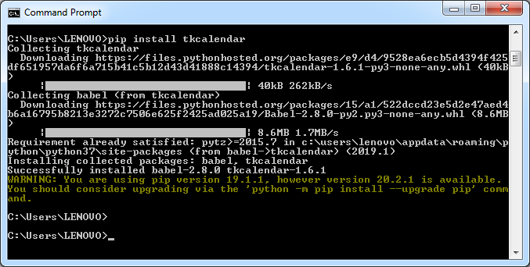

The name of the python code file is StudentManager.py After executing the file the application window is displayed below. In that window a new student record can be added. All the added records in MySQL database table are displayed in a Tkinter Treeview widget.

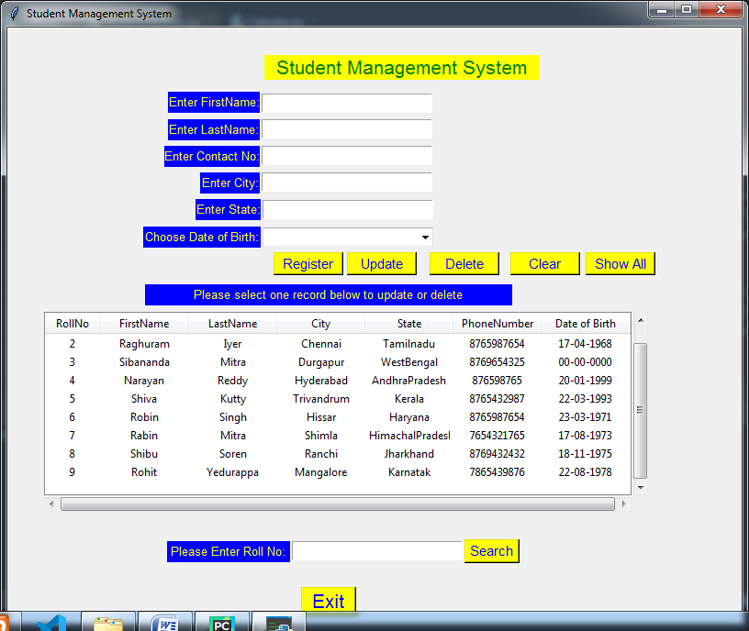

**Inserting Student Record.**

All the student data is filled up and date of birth is choosen from drop down calendar widget as shown below and register button is clicked to add the record to database.

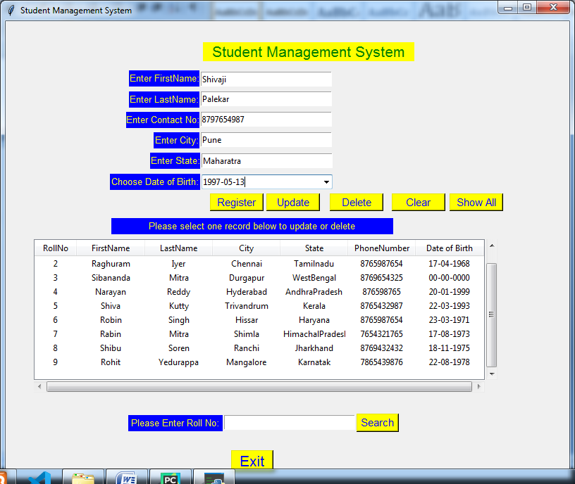

Student Record is inserted successfully.It is displayed below.

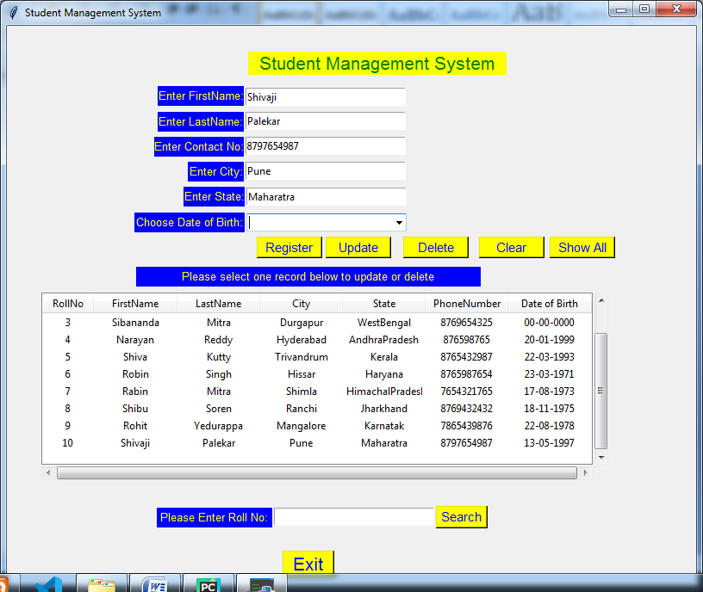

In the inserted record state name is spelled wrong and we will change date of birth, so record is to be updated. Please select the record in the displayed widget by clicking it. All data is displayed in the above boxes to update and delete the record.

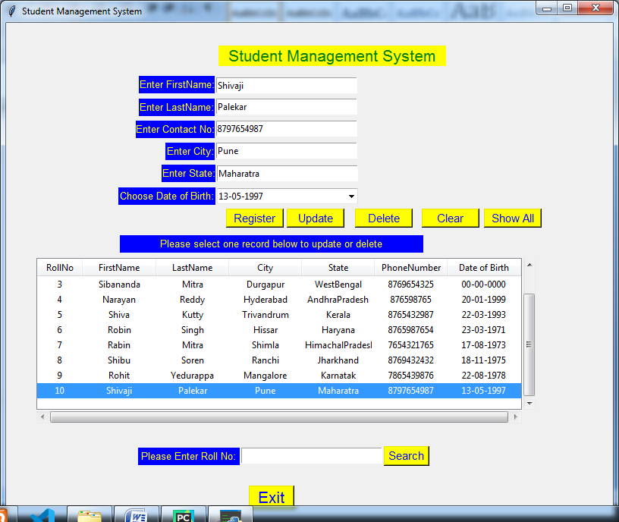

Please edit the fields displayed in boxes and update by clicking Update button.



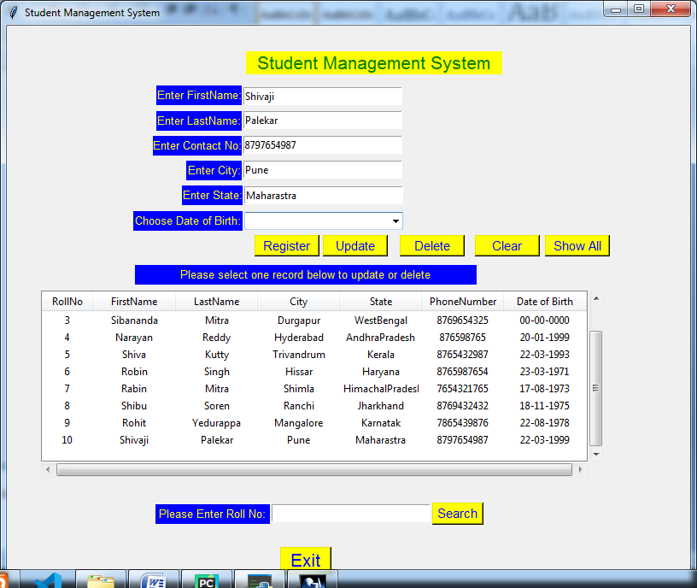

A student record can be searched by entering roll no and clicking search button as shown below.

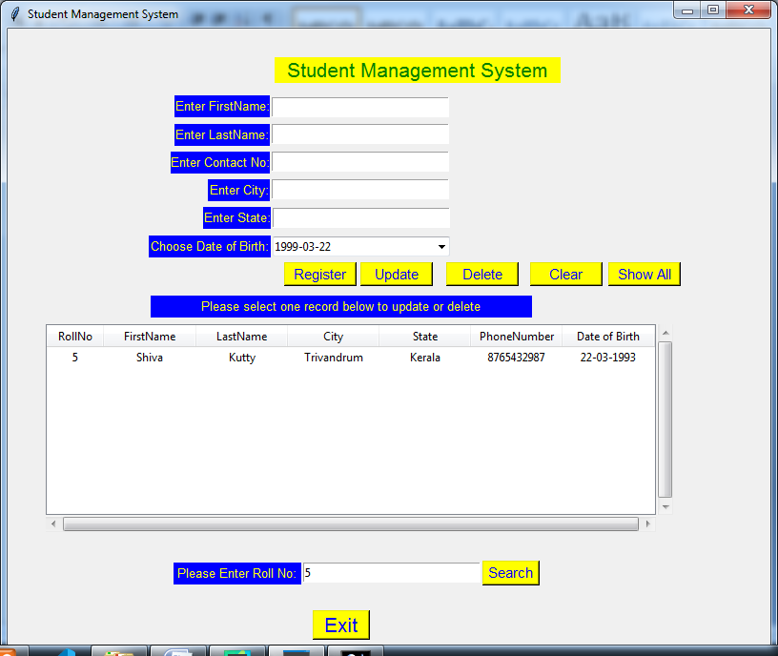

To display all records please click Show All button.

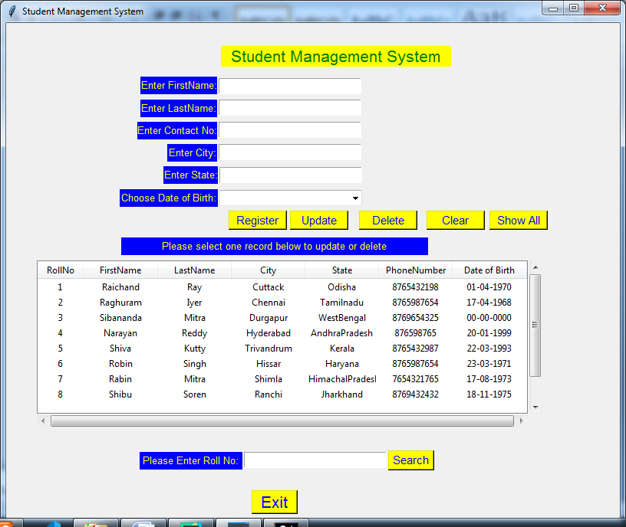

To Delete a record please select the record in the display widget and click delete button.

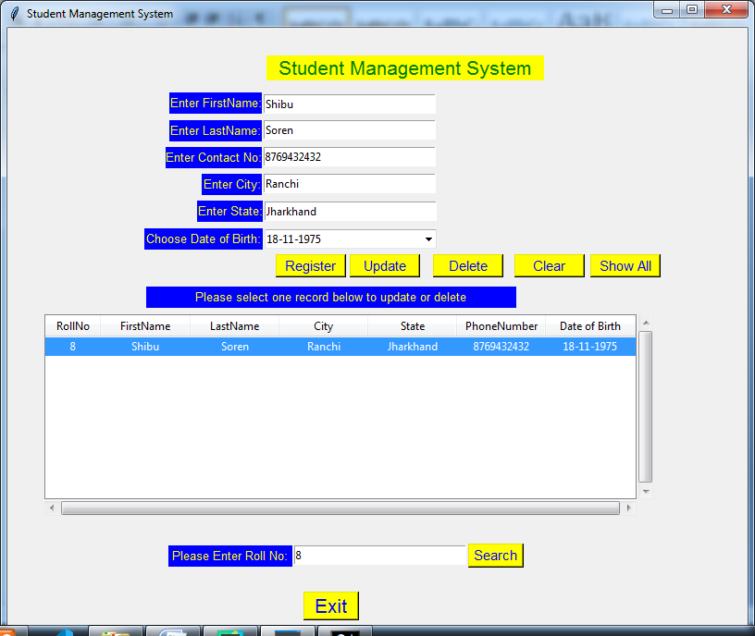

References

1. Tkinter GUI application development cookbook by Alejandro Rodas de Paz of Packt Publications

2.Home and Learn website <https://www.homeandlearn.uk/index.html> for learning python language.

3.Stackoverflow.com